**Paap & Liu (2014)**

**Conflict resolution in sentence processing is the same for bilinguals and monolinguals:**

**The role of confirmation bias in testing for bilingual advantages**

Experiment 1:

Motivation: Following Gernsbacher, Varner & Faust (1990), who anticipated that more skilled comprehenders enhance the activation of relevant information while suppressing the activation of less relevant information. Their task required participants to read a sentence ending in either a homograph or a control word and judge if the test word that followed matched the meaning of the sentence they just read:

*“He dug with the spade/shovel. ***ACE\*\*\**

* Task involves suppressing irrelevant conceptual information (spade1 vs ~~spade~~~~2~~)
* Bilinguals have to suppress irrelevant phonological or orthographic information
  + (spade vs ~~espada~~)
* If only the specific ability of suppressing translation equivalents is suppressed, we wouldn’t expect an advantage for bilinguals, but if bilingualism develops inhibitory control, they should show less homograph interference.

Participants:

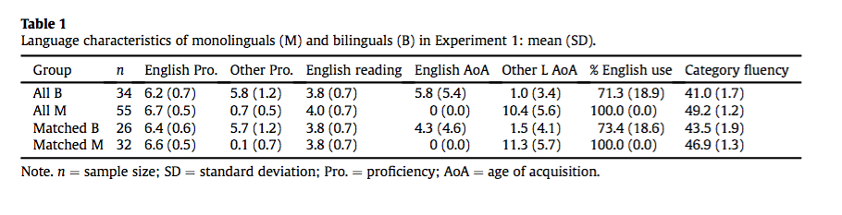

Materials:

* 120 sentences, each ending with a homograph, expected to be known by L2 speakers
* Homograph meaning frequency: M = .58 (inappropriate) and M = .25 (appropriate)
  + Authors want a robust interference effect
* Eight conditions: final word type {homograph, control}, answer to question {yes, no}, level of ISI {immediate = 100 ms, delayed = 850 ms}
* NO items were considered critical and were balanced across participants

Procedure:

**Results**:

“If there is a bilingual advantage in inhibitory control then, other factors equal, bilinguals should be less vulnerable to interference from the context-inappropriate meaning of a homograph, but only when the test is delayed and the sentence context has sufficient time to suppress the inappropriate meaning.”

Reaction Time:

*Main effects:*

Homographs resulted in longer RTs than control words (61 ms): *F*(1,87) = 84.73, *p* < .001, partial *n*2 = .49

Delayed ISI were faster than immediate ISI responses (52 ms): *F*(1,87) = 55.61, *p* < .001, partial *n*2 = .39

Monolinguals were faster than bilinguals (238 ms): *F*(1,87) = 84.73, *p* < .001, partial *n*2 = .49

*Interactions:*

Last Word X Group: the homograph-interference effect is larger for bilinguals (M = 79 MS) than monolinguals (M = 42 ms): *F*(1,87) = 7.84, *p* < .006, partial *n*2 = .08

Group X Delay: not significant

Group X Delay X Last Word: not significant

Accuracy of ‘No’ responses:

* Main effect: Last word (controls 9.9% more accurate)
* Main effect: Group (monolinguals 6.4% more accurate)
* Interactions: Group X Last Word: *F*(1, 87) = 14.60, *p* < .001, partial *n*2 = .14.
  + - The homograph interference effect is 13.2% for the bilinguals compared to only 6.6% for the monolinguals.

Z-score analysis:

* To test hypothesis that bilinguals better reduce the size of their standardized interference effect with more time for inhibitory control to act
* Only significant interaction: Last Word X Delay F(1,87) = 5.62, *p* < .020, partial *n*2 = .06.
* Group X Last Word X Delay: not significant: *F*(1,87) = 0.27, *p* = .603

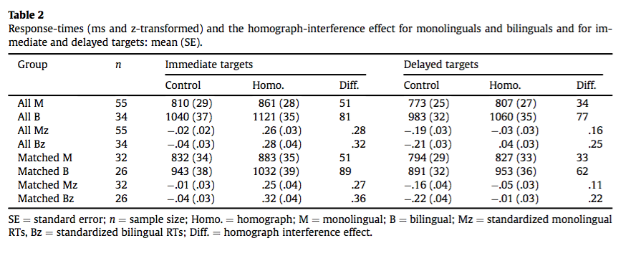

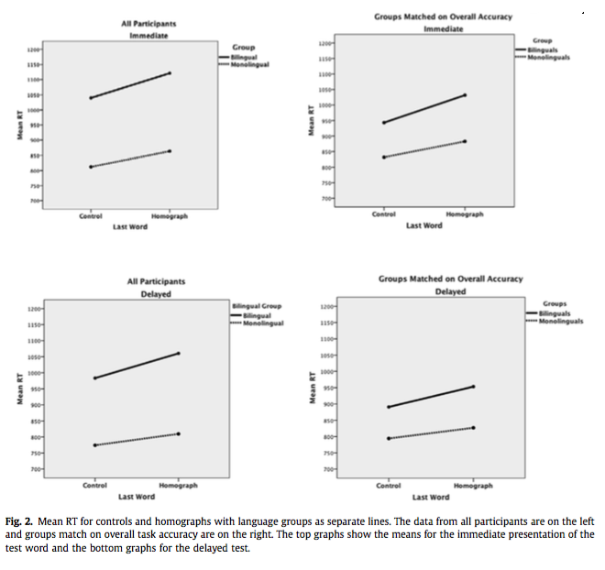Matched performers:

* Bilinguals who made > 200 correct responses (> 83% correct): N = 26, 91% acc
* Monolinguals with < 230 correct responses (<96% correct): N = 32, 91.4% acc
* Main effects:
  + Last Word: Homographs > control words (59 ms)
    - *F*(1, 56) = 54.89, *p* < .001, partial *n*2 = .50
  + Delay: Responses 56 ms faster after ISI delay
    - *F*(1, 56) = 39.84, *p* < .001, partial *n*2 = .42
  + Group: Monolinguals faster by 122 ms
    - 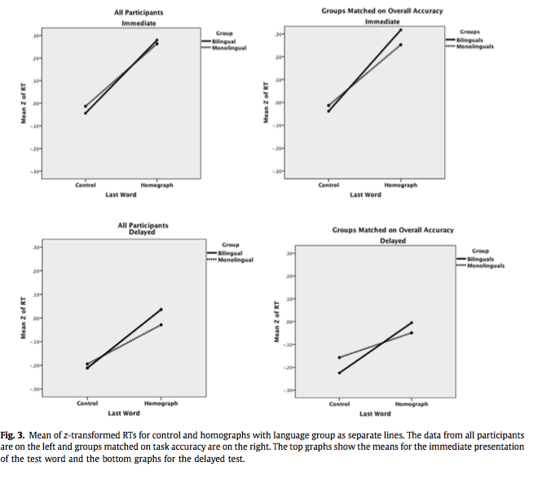*F*(1, 56) = 6.58, *p* = .013, partial *n*2 = .10
* Interactions:
  + Group X Last Word: homograph-interference effect is larger for bilinguals (M = 76 ms) than for monolinguals (M = 42 ms)
    - *F(*1, 56) = 4.25, *p* = .038, partial *n*2 = .07
  + Critical Group X Last Word X Delay: not significant
    - When groups are matched on overall accuracy the slopes for bilinguals and monolinguals are very similar

Matching & Z-scores:

* Main effect, Last word:
  + *F*(1, 56) = 66.85, *p* < .001, partial *n*2 = .54
* Main effect, Delay
  + *F*(1, 56) = 53.17, *p* < .001, partial *n*2 = .49
* Interaction, Last Word X Delay: homograph interference effect was greater immediately (.31 z) than after a delay (.16 z)
  + *F*(1,56) = 9.47, *p* = .003, partial *n*2 = .15.
* The critical Group X Last Word X Delay interaction was not significant
  + The nonsignificant trend is for monolinguals to show less homograph interference after a delay.

Discussion:

* Bilinguals showed more interference when all participant data are considered
  + Mean RT and z-scores, and regardless of delay of ISI
* RT difference favoring monolinguals diminishes when participants are matched on overall accuracy
  + Primary difference: both groups benefit from delayed ISI
* Can the lexical quality hypothesis (Hart & Perfetti, 2008; Perfetti & Hart, 2002) provide answers to this? Monolinguals have richer connections between concepts and their lexical forms?

**Experiment 2:**

Motivation: Following Moreno, Bialystok, Wodniecka, and Alain (2010), who conclude that bilinguals have enhanced executive control as they close the performance gap when a sentence judgment task involves conflict resolution, comparing performance on task with 4 conditions (+/- semantic error; +/- syntactic error)

Issues with Moreno et al. (2010):

1. Do not report RTs because there is a 1450 ms ISI.
2. Do not balance order of tasks
3. Report separate ANOVAs for each of the two tasks.
4. Conclude that the bilinguals superior EP enabled them to overcome the monolingual advantage shown in the *easy* acceptability task by employing their superior inhibitory control in the *more* *difficult* and EP demanding grammaticality task.
5. Assume that the grammaticality task is more difficult than the acceptability task, but accuracy is higher in the grammaticality task

Participants:

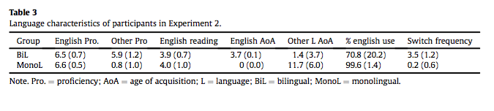

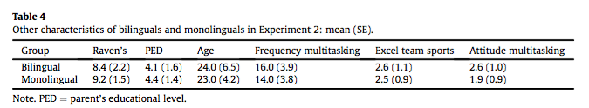

Materials:

Same 120 sentences used by Moreno et al. (2010), but self-paced reading

4 conditions: (1) correct in both semantics and syntax; (2) semantically anomalous, syntactically correct; (3) semantically fine, syntax violation; (4) both semantic anomaly & syntactic violation

Procedure:

**Accuracy Results:**

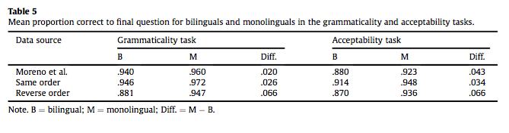

Moreno et al. (2010): Monolinguals statistically outperform bilinguals in acceptability but not grammaticality task.

Current study, same order: Monolinguals descriptively outperform bilinguals in acceptability but not grammaticality task

* *F*(1, 22) = 3.90, *p* = .061, partial *n*2 = .151
* *F*(1, 22) = 2.66, *p =* .117, partial *n*2 = .108.
* However, no Group X Task interaction, i.e. no evidence that bilinguals “catch up”

Current study, reverse order: Monolingual advantages of 6.6% for both tasks.

Full factorial analysis:

* All of the main effects were significant:
* monolinguals (M = 95.3%) were more accurate than bilinguals (M = 90.3%)
  + *F*(1, 44) = 20.51, *p* = .001, partial *n*2 = .318
* Semantic anomalies (M = 87.7% correct) were more error prone than correct sentences (M = 94.7%) or those with syntactic violations (95.9%)
  + F(2, 88) = 27.39, p < .001, partial *n*2 = .384
* Grammaticality task (M = 93.8%) was easier than the acceptability task (M = 91.7%)
  + F(1, 44) = 4.60, p = .037, partial *n*2 = .095
* Order used by Moreno et al. (M = 94.7%) was easier than the reverse order (M = 90.8%) when the acceptability task was done first
  + F(1, 44) = 9.81, p = .003, partial *n*2 = .182.

**Reaction Time Results:**

* No main effect of group: bilinguals were less accurate but not slower
  + F(1, 44) = 0.299, p = .588, partial *n*2 = .007.
* No significant interactions for Group
  + Thus, the RT data provide no evidence that monolinguals and bilinguals differ in the speed of making grammaticality or acceptability judgments
* Main effect: Task: mean RT in grammaticality task (629 ms) was faster than the mean in the acceptability task (681 ms)
  + F(1, 44) = 7.629, p = .008, partial *n*2 = .148
* Task X Order interaction was also significant, F(1, 44) = 23.186, p < .001, partial *n*2 = .345.
* Reading time to critical word: reading times to the critical word are the same for bilinguals and monolinguals, the same for both tasks (no interactions with Group)
* Reading time to sentence-final word: Main effect of sentence type, F(2, 88) =40.20, p < .001, partial *n*2 =.477.
  + Both correct (M =+123 ms) and sentences with semantic anomalies (M =+163) took longer than predicted from their length, whereas syntax violations were faster than predicted (M = -54 ms).

**Conclusion:**

**Experiment 1 finds no inhibitory advantage for bilinguals, monolinguals inhibit homograph’s inappropriate meaning better than bilingual peers, even in matched analyses.**

**Experiment 2 finds no bilingual advantage in terms of conflict resolution/executive processing as proposed by Moreno et al. (2010).**

**Pozzan & Trueswell (2015)**

**Second language processing and revision of garden-path sentences: a visual word study**

Motivation:

* We know the child (L1) learner shows less ability to revise than adults. This has been linked to immature cognitive control and EF skills (Choi & Trueswell, 2010; Novick, Trueswell & Thompson-Schill, 2005; Woodard, Pozzan & Trueswell, 2016), the idea being that EF skills are engaged when abandoning a preferred analysis for a NONpreferred one.
* If this inability relates to the immaturityof the child’s EF, not related to learning phenomena, we shouldn’t see the same pattern in L2 learners.

*Native adult processing*: 2-referent contexts are typically associated with fewer looks to the incorrect goal and fewer signs of processing difficulty as compared to 1-referent contexts (Tanenhaus, Spivey-Knowlton, Eberhard & Sedivy, 1995; Spivey, Tanenhaus, Eberhard & Sedivy, 2002).

*Child processing*: Referential effects are not reliably observed (Snedeker & Trueswell, 2004; Trueswell & Gleitman, 2007).

Participants:

L2 participants: 33 Italian learners of English, intermediate level (MTELP);

Age: 23-60, M = 30.75

L1 controls: 30 native English speakers

Age: 18-25, M = 19.5

Materials:

24 experimental sentences in 2x2 design (ambig vs unambig.; 1-ref vs 2-ref), followed by one or two filler sentences

36 filler trials (Put the pear near the stapler), followed by filler sentences.

**Behavioral Results:**

L2 learners more error-prone than native speakers

Ambiguous sentences led to higher error rates than unambiguous sentences.

2-referent contexts led to fewer errors than 1-referent contexts

3-way Interaction:

L2 errors were particularly high in response to ambiguous sentences in 1-referent contexts

* Here, L2 participants’ error rates were numerically comparable to those observed in children in Trueswell et al. (1999).

While L2 speakers were less accurate than native adults, particularly in ambiguous contexts, they benefited from referential cues, while children did not, as they performed better in 2-referent contexts.

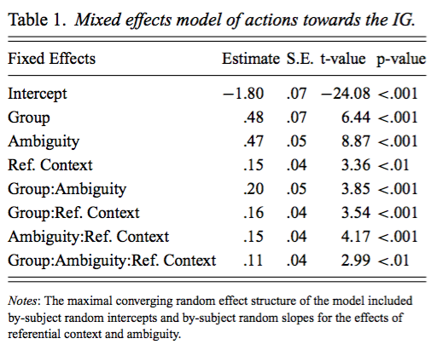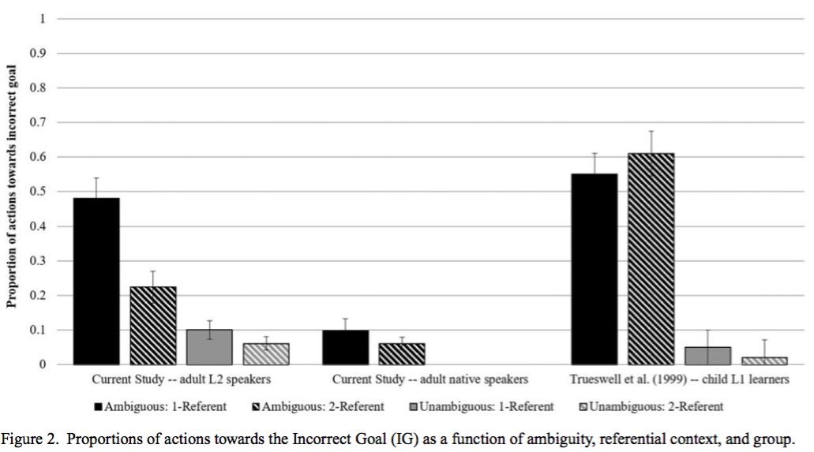

**Eye-tracking Results:**

* Ambig. sentences associated with more looks to incorrect goal than unambig. sentences
* 1-referent contexts associated with more looks to incorrect goal than 2-referent contexts

Interactions:

Referential context X Ambiguity

Group X Ambiguity

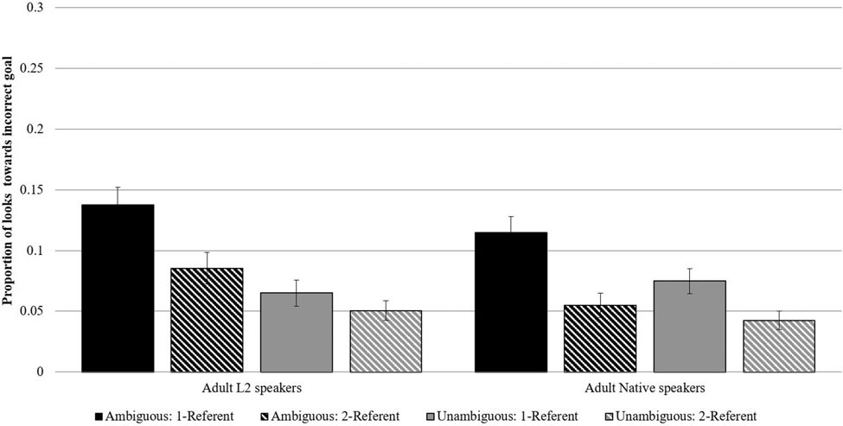 Figure 3. Proportions of looks to the IG as a function of ambiguity, referential context and group during the time window from the onset of the critical prepositional phrase (e.g., “on the napkin”) until disambiguating information (i.e., onset of “box”).

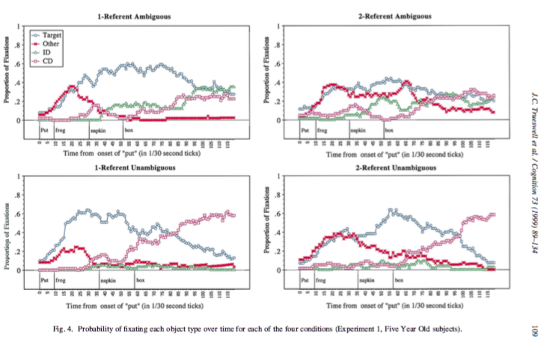

Model with main effects of ambiguity, referential context, and language group, together with all interactions, to predict the obtained residuals.

* Consideration of the incorrect goal was a significant predictor of act-out errors (*Estimate* = .21, *SD* = .04, *p* < .001)
* However, all critical effects survived even when relationship between Group X Ambiguity interaction was taken into account.
* Suggests that L2 learners differ from natives in ability to abandon an incorrect parse after hearing disambiguating information, “above and beyond the presence of differences during early processing commitments.”
* Both groups of adults use referential information early in processing to help parsing.

**Conclusion:**

* **Online processing similar for both adult groups**
  + **Higher consideration of incorrect goal**
  + **Early consideration of referential information (L1 transfer?)**
* **Act-out patterns were less accurate for L2 leaners, and comparable to native children**
  + **Are LIFG and other prefrontal structures recruited during L2 processing more than L1?** 
    - **Difficulties of revision could stem from cognitive overload**
    - **Incorporate EF measures in future studies to test this**